**Year 12 ATAR Biology**

**Unit 4: Infectious Diseases Test**

**Section One: Multiple Choice** (20 marks)

Mark your answers on the answer grid provided on the front cover of the answer booklet.

_____________________________________________________________________________________

The graph below shows the characteristic shape for the population growth of a pure, sealed culture of bacteria. Use this information to answer questions 1 and 2.

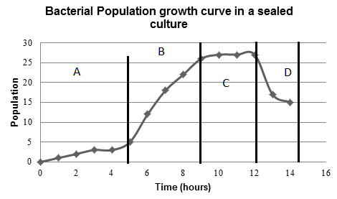

1. Which phase of the graph represents the stage of population growth where death rate is equal to the rate of cell division?
2. A
3. B
4. C
5. D

2. Which phase of the graph represents the stage where there is limited competition between the bacteria in the culture?

1. A
2. B
3. C
4. D
5. Disease that can be transmitted between animals and humans is termed

(a) a fomite.

(b) pandemic.

(c) epizootic.

(d) zoonotic.

1. Vectors are important in the spread of many diseases. It is reasonable to suggest that
2. vectors are the organisms that can infect an individual and cause disease in the host.
3. vectors are involved in the transmission of viral diseases only.
4. diseases associated with a particular vector are usually restricted to the geographical area that supports that vector.
5. insects are the only organisms that can act as vectors.
6. Eight sick animals were found to be suffering from the same symptoms. Blood tests showed that they were infected with the same type of bacterium. Which of the following strategies would be the best to determine if this particular type of bacterium is the cause of the disease?

(a) Find other animals with the same symptoms and attempt to isolate the same type of bacterium from their blood.

(b) Inject blood from animals with the symptoms into suitable host individuals. If they develop the same symptoms, this proves that this type of bacterium caused the disease.

(c) Use bacteria cultured from the blood of the animals with these symptoms to infect suitable host individuals. If they develop the disease, attempt to isolate the same type of bacterium from their blood.

(d) Treat all eight animals with an antibiotic known to kill this type of bacterium. They will recover if this type of bacterium is the cause of the disease.

1. Overseas equestrian competitors brought their horses to Australia for the Sydney 2000 Olympic Games. Why were the horses quarantined for a period of time before the Olympic Games began?

(a) To acclimatise them to Australian weather conditions.

(b) To make sure that no horse diseases spread to the spectators.

(c) To make sure that the horses did not contract Australian diseases.

(d) To make sure that the horses did not have an infectious disease.

Questions 7 and 8 refer to the diagram below.

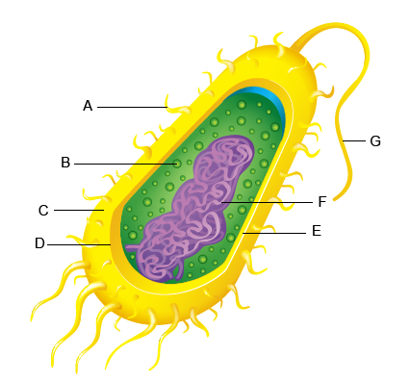

<http://www.proprofs.com/quiz-school/story.php?title=bacteria-quiz>

1. [Which best classifies the cell shown?](http://www.helpteaching.com/questions/303832/which-best-classifies-the-cell-shown)

(a) plant

(b) animal

(c) bacterial

(d) protozoan

1. [Which structure is represented by the letter B on the bacterial cell diagram?](http://www.helpteaching.com/questions/303835/which-structure-is-represented-by-the-letter-a-on-the-bacter)

(a) pilus

(b) nucleoid

(c) ribosome

(d) flagellum

1. A typical virus consists of

(a) a protein coat and a cytoplasm core

(b) a carbohydrate coat and a nucleic acid core

(c) RNA or DNA in a protein coat

(d) a polysaccharide coat and a nucleic acid core

10. Most parasites do not kill their hosts because, in order to live, they require their hosts to continue living too. However, parasitic fungi can kill their hosts and continue to thrive. What is the likely reason for this?

(a) Fungi can always easily find a new host.

(b) Fungi can continue to absorb energy by decomposing the dead organic material.

(c) Fungi can make their own energy until a new host is available.

(d) Fungi can stop using energy until a new host is available.

11. Bacteria adapt more quickly than elephants to environmental changes. Which best explains the difference?

(a) Bacteria reproduce more quickly, speeding up the process of natural selection.

(b) Bacteria move more quickly, allowing them to migrate easier.

(c) Elephants have more genes, so they mutate slower.

(d) Elephants are not affected by antibiotics.

12. Which of the following statements can be used to describe a pathogen?

(a) They are all viral.

(b) They are all infectious.

(c) They are all microscopic.

(d) They are all macro-parasites.

13. Recently, hospitals and medical practitioners have warned the community about the spread of severe acute respiratory syndrome (SARS). People were experiencing:

* high temperatures
* body aches
* pains similar to that of the flu.

How would you classify these descriptions?

(a) Controls

(b) Symptoms

(c) Warnings

(d) Methods of transmission

14. Which of the following is an example of quarantine used to control the spread of disease across regions of Australia?

(a) Killing weeds in infested forests using herbicides and direct removal

(b) Sterilisation of all food products that come from overseas

(c) Sterilisation of all food products before packaging

(d) Removal of fruit from cars travelling interstate

15. During the last 50 years, over-use of prescription drugs has led to the emergence of resistant strains of particular pathogenic bacteria. Why is this a problem?

(a) A single prescription drug can no longer kill all strains of a pathogen.

(b) Many diseases will lose their ability to cause disease.

(c) Resistant pathogens will cause new types of diseases.

(d) Prescription drugs will cause the release of toxins by pathogens.

16. Students performed an investigation to compare the effectiveness of two water treatments for purifying pond water. Three samples of pond water, *A*, *B* and *C,* were collected and each used to inoculate an agar plate. The plates were incubated at 25°C and examined three days later. The number of visible bacterial colonies on each plate was counted and the results tabulated.

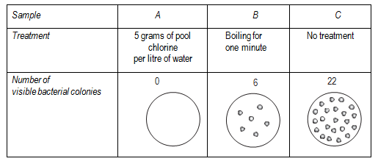

What is the dependent variable in this investigation?

(a) The use of a control sample.

(b) The number of visible bacterial colonies.

(c) The use of sterile agar plates for each sample.

(d) Treating the water by boiling or adding pool chlorine.

17. Fomites are

1. animals that carry disease that can spread to humans.
2. Living vectors that carry disease.
3. Drugs that can be used to treat malaria
4. Non-living objects that act as vehicles for infectious diseases.

18. Which of the following differentiates correctly between antibiotics and vaccines?

(a) Antibiotics provide long lasting immunity due to the production of memory cells, while vaccines only provide short term immunity.

(b) Antibiotics treat for an invading pathogen, while many vaccines involve the introduction of an inactivated pathogen into the bloodstream.

(c) Antibiotics provide artificial, active immunity, while vaccines provide artificial, passive immunity.

(d) Antibiotics are often injected into the bloodstream, while vaccines are normally ingested in pill form.

19. An intermediate host which carries a pathogen that causes a disease from one organism to another is called

(a) an antibiotic

(b) a zoosporangium

(c) an endemic species

(d) a vector

20. Which of the following helps prevent the entry of pathogens into humans?

(a) Cilia

(b) Antigens

(c) B lymphocytes

(d) Inflammation response

**Year 12 ATAR Biology**

Unit 4: Infectious Diseases Test

Section 1 M/C ___________20

Section 2 S/A ___________30

NAME _________________________________________ Total ______________ / 50

**Section One: Multiple Choice (20 marks)**

Mark your answers on the answer grid below.

|  |  |  |  |  |  |  |  |  |  |  |
| --- | --- | --- | --- | --- | --- | --- | --- | --- | --- | --- |
| **Question** |  | | | |  | **Question** |  | | | |
| **1** | **A** | **B** | **C** | **D** |  | **11** | **A** | **B** | **C** | **D** |
| **2** | **A** | **B** | **C** | **D** |  | **12** | **A** | **B** | **C** | **D** |
| **3** | **A** | **B** | **C** | **D** |  | **13** | **A** | **B** | **C** | **D** |
| **4** | **A** | **B** | **C** | **D** |  | **14** | **A** | **B** | **C** | **D** |
| **5** | **A** | **B** | **C** | **D** |  | **15** | **A** | **B** | **C** | **D** |
| **6** | **A** | **B** | **C** | **D** |  | **16** | **A** | **B** | **C** | **D** |
| **7** | **A** | **B** | **C** | **D** |  | **17** | **A** | **B** | **C** | **D** |
| **8** | **A** | **B** | **C** | **D** |  | **18** | **A** | **B** | **C** | **D** |
| **9** | **A** | **B** | **C** | **D** |  | **19** | **A** | **B** | **C** | **D** |
| **10** | **A** | **B** | **C** | **D** |  | **20** | **A** | **B** | **C** | **D** |

**Section Two: Short answer (30 marks)**

Answer all questions in this section in the space provided.

_____________________________________________________________________________________

Question 21 (4 marks)

Compare and contrast the following terms:

1. Pathogenicity and virulence. (2 marks)

__________________________________________________________________________________________________________________________________________________________________________

__________________________________________________________________________________________________________________________________________________________________________

__________________________________________________________________________________________________________________________________________________________________________

1. Epidemic and Pandemic. (2 marks)

__________________________________________________________________________________________________________________________________________________________________________

__________________________________________________________________________________________________________________________________________________________________________

__________________________________________________________________________________________________________________________________________________________________________

Question 22 (6 marks)

Whooping cough is a disease that affects some infants. Doctors collected data relating to whooping cough between 1965 and 1996. They collected data for the number of cases of whooping cough reported and the percentage of infants vaccinated against whooping cough.

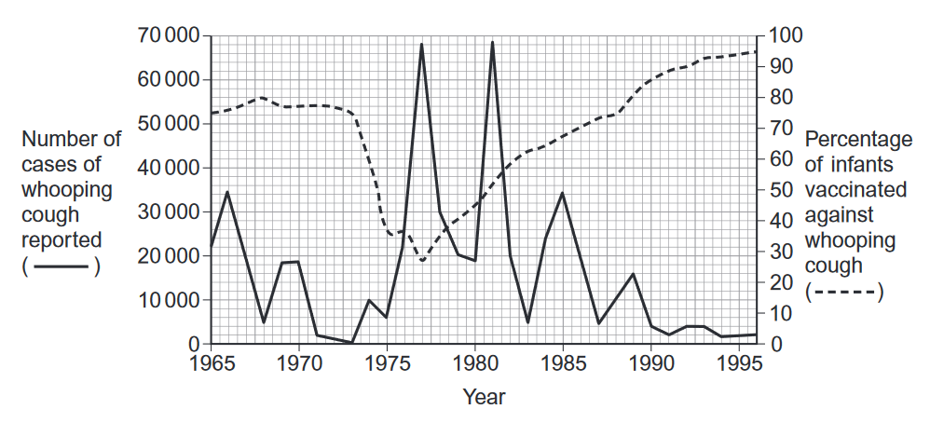

1. Suggest two reasons why the percentage of infants vaccinated decreased between 1973 and 1975.

(2 marks)

____________________________________________________________________________________________________________________________________________________________________________________________________________________________________________________________________________________________________________________________________________________

1. Between 1980 and 1990 there were three peaks in the number of reported cases of whooping cough. After 1981 the number of cases of whooping cough in each peak decreased. Use the information in the graph to suggest reasons why. (2 marks)

____________________________________________________________________________________________________________________________________________________________________________________________________________________________________________________________________________________________________________________________________________________

1. The percentage of the population vaccinated does not need to be 100% to be effective in preventing the spread of the disease. Explain why. (2 marks)

____________________________________________________________________________________________________________________________________________________________________________________________________________________________________________________________________________________________________________________________________________________

Question 23 (20 marks)

Malaria and Ross River are both diseases described as being mosquito borne diseases.

1. List the symptoms and treatments for Malaria and Ross River virus in the table below. (6 marks)

|  |  |  |
| --- | --- | --- |
|  | Malaria | Ross River |
| Symptoms |  |  |
| Treatment |  |  |

1. Use a flow diagram to describe to lifecycle of Malaria. (5 marks)
2. Describe and explain two ways a person can prevent themselves contracting Malaria. (4 marks)

__________________________________________________________________________________________________________________________________________________________________________

__________________________________________________________________________________________________________________________________________________________________________

__________________________________________________________________________________________________________________________________________________________________________

1. Through the Mozzie Wise school education program run by Sercul, school children are educated on the life cycle of the mosquito and how the environment can be managed to reduce the prevalence of mosquitos in urban area. Describe and explain two strategies that can be employed in the environment to reduce the population of particular mosquito species which transmit disease.

(2 marks)

__________________________________________________________________________________________________________________________________________________________________________

__________________________________________________________________________________________________________________________________________________________________________

__________________________________________________________________________________________________________________________________________________________________________

1. The distribution of Malaria around the world is influenced by many factors including climate change. Describe why and how climate change could impact on the global distribution of the disease.

(3 marks)

__________________________________________________________________________________________________________________________________________________________________________

__________________________________________________________________________________________________________________________________________________________________________

__________________________________________________________________________________________________________________________________________________________________________

__________________________________________________________________________________________________________________________________________________________________________

_____________________________________________________________________________________

__________________________________________________________________________________________________________________________________________________________________________

_____________________________________________________________________________________

__________________________________________________________________________________________________________________________________________________________________________